To change (default) deliver addresses in TechBuy
Log-in into TechBuy system (http://techbuy.ttu.edu)
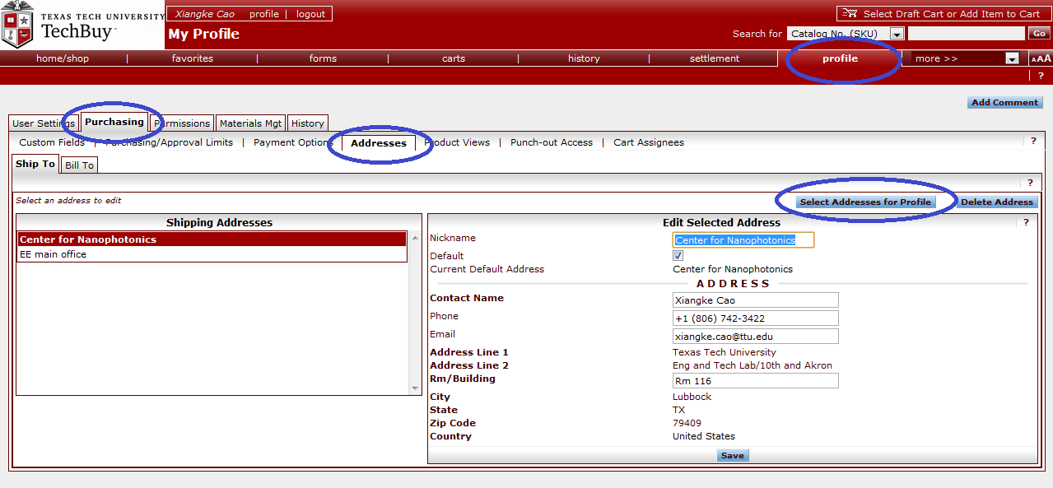
Goto “Profile” => “Purchasing” => “Addresses” and click “Select Addresses for Profile”.
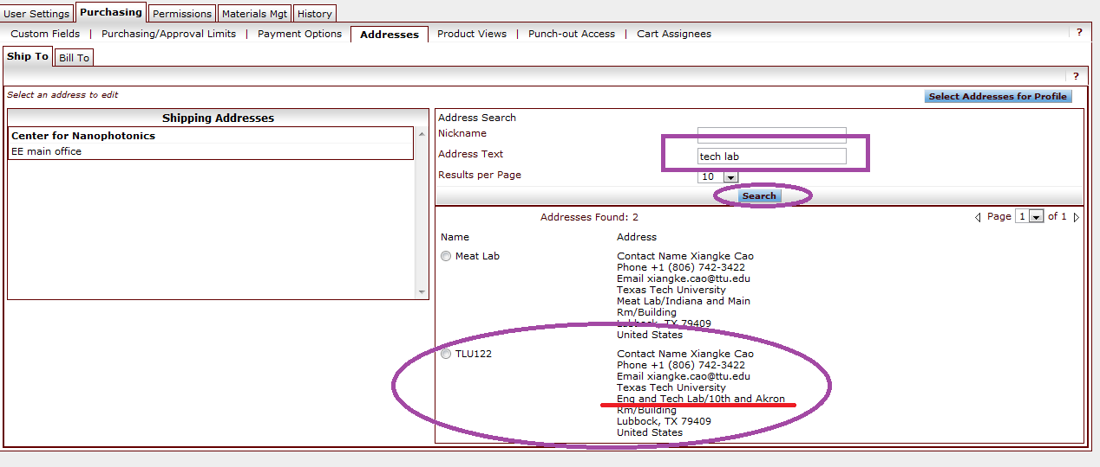
In the new interface, Type “tech lab” in “Address Text” line and press “Search”. Then select our lab address

…Continue to next page

Nickname you address and remember to check it as “Default”. (Always deliver items to out lab when you order)
Click “Save” after type in your name, phone number, email address and room number.
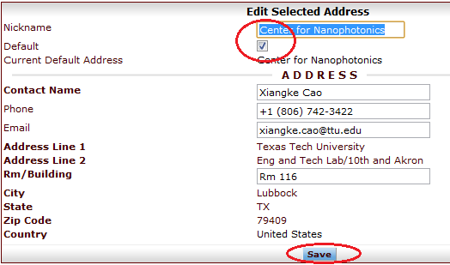

Still double check the address when you put-up orders. Contact Xiangke or I-Wen if you have further questions.

